12. Cross-Classified Models EPSY 8268

Cross-Classification

Many cases exist where the units of observations belong to multiple higher-level units simultaneously. For example, students live in neighborhoods and attend schools, or students may have two different teachers simultaneously. Another example includes patients working with doctors and hospitals where hospitals take referrals from multiple doctors and doctors refer patients to various hospitals. Such models allow for a variety of analysis goals:
- Partition variance among students, schools, and neighborhoods
- Investigate the roles of characteristics of neighborhoods and schools
- Investigate the extent to which the associations between student characteristics and outcomes vary over neighborhoods and schools
- Estimate the unique effects of neighborhoods and schools

Level-1 Model within cell

Y_{ijk} = π_{0jk} + e_{ijk} where e_{ijk} ~ N(0, σ²)

A model for outcome y for case i nested within row j and column k of a two-way classification.
π_{0jk} is the expected value of Y_{ijk} within cell jk (neighborhood × school). In this case e_{ijk} is the unique child effect, the deviation of the score for child ijk from the cell mean, and σ² is the within cell variance.

Level-2 Models between cell

π_{0jk} = θ₀ + b_{00j} + c_{00k} where b_{00j} ~ N(0, τ_{b00}) and c_{00k} ~ N(0, τ_{c00})

θ₀ is the grand mean of Y
b_{00j} is the neighborhood j effect, averaged over all schools
c_{00k} is the school k effect, averaged over all neighborhoods

Neighborhood by School Crosstabulation (a sample of Schools & Neighborhoods)

Neighborhood ID |  | School ID |  |  |  |  |  |  |  |  |  | Total
 |  | 0 | 3 | 5 | 8 | 15 | 16 | 17 | 18 | 19 | 20
 | 29 | 0 | 0 | 0 | 0 | 0 | 0 | 0 | 1 | 0 | 8 | 9
 | 32 | 0 | 0 | 0 | 0 | 0 | 0 | 0 | 1 | 0 | 5 | 6
 | 38 | 0 | 0 | 0 | 0 | 0 | 0 | 0 | 1 | 0 | 4 | 5
 | 39 | 0 | 0 | 0 | 0 | 0 | 0 | 0 | 1 | 0 | 2 | 3
 | 40 | 0 | 0 | 0 | 0 | 0 | 0 | 0 | 0 | 0 | 4 | 4
 | 47 | 0 | 0 | 0 | 0 | 0 | 0 | 0 | 2 | 0 | 6 | 8
 | 48 | 0 | 0 | 0 | 0 | 0 | 0 | 0 | 1 | 0 | 4 | 5
 | 53 | 0 | 0 | 0 | 0 | 0 | 0 | 0 | 3 | 0 | 1 | 4
 | 54 | 0 | 0 | 0 | 0 | 0 | 0 | 0 | 1 | 0 | 3 | 4
 | 67 | 0 | 0 | 0 | 0 | 0 | 0 | 0 | 1 | 0 | 4 | 5
 | 68 | 0 | 0 | 0 | 0 | 0 | 0 | 0 | 2 | 0 | 4 | 6
 | 69 | 0 | 0 | 0 | 0 | 0 | 0 | 0 | 1 | 0 | 6 | 7
 | 189 | 0 | 0 | 0 | 0 | 0 | 0 | 0 | 0 | 2 | 0 | 2
 | 190 | 0 | 0 | 0 | 0 | 1 | 0 | 0 | 0 | 6 | 0 | 7
 | 191 | 0 | 0 | 0 | 0 | 0 | 0 | 0 | 1 | 2 | 0 | 3
 | 192 | 0 | 0 | 0 | 0 | 0 | 0 | 0 | 0 | 5 | 0 | 5
 | 193 | 0 | 0 | 0 | 0 | 0 | 0 | 1 | 1 | 2 | 0 | 4
 | 194 | 0 | 0 | 0 | 0 | 0 | 0 | 0 | 0 | 4 | 0 | 4
 | 195 | 0 | 0 | 0 | 0 | 2 | 0 | 0 | 0 | 7 | 0 | 9
 | 197 | 0 | 0 | 0 | 0 | 2 | 0 | 1 | 2 | 0 | 0 | 5
 | 216 | 0 | 0 | 0 | 0 | 4 | 1 | 6 | 1 | 0 | 0 | 12
 | 229 | 0 | 0 | 0 | 0 | 1 | 0 | 8 | 2 | 1 | 0 | 12
 | 263 | 0 | 0 | 0 | 0 | 14 | 0 | 1 | 1 | 0 | 0 | 16
 | 710 | 1 | 10 | 1 | 1 | 0 | 0 | 0 | 0 | 0 | 0 | 13
 | 711 | 0 | 5 | 0 | 1 | 0 | 0 | 0 | 0 | 0 | 0 | 6
 | 712 | 0 | 9 | 0 | 2 | 0 | 0 | 0 | 0 | 0 | 0 | 11
 | 713 | 0 | 7 | 0 | 1 | 0 | 0 | 0 | 0 | 0 | 0 | 8
 | …
Total |  | 146 | 159 | 155 | 112 | 190 | 111 | 154 | 91 | 102 | 174 | 2310

Example:

Garner and Raudenbush (1991) studied a sample of 2310 students from 524 neighborhoods (row factor) attending 17 schools (column factor) in Scotland. The outcome variable is a composite measure of academic achievement (total attainment) across a series of national exams.

Data input into HLM includes a level-1 file (within cell) with student information, a level-2 row-factor file with neighborhood information, and a level-2 column-factor file with school-level information. The level-1 within-cell file includes IDs for both level-2 factors.

Level-1 File
Educational attainment; primary 7 verbal reasoning, primary 7 reading…
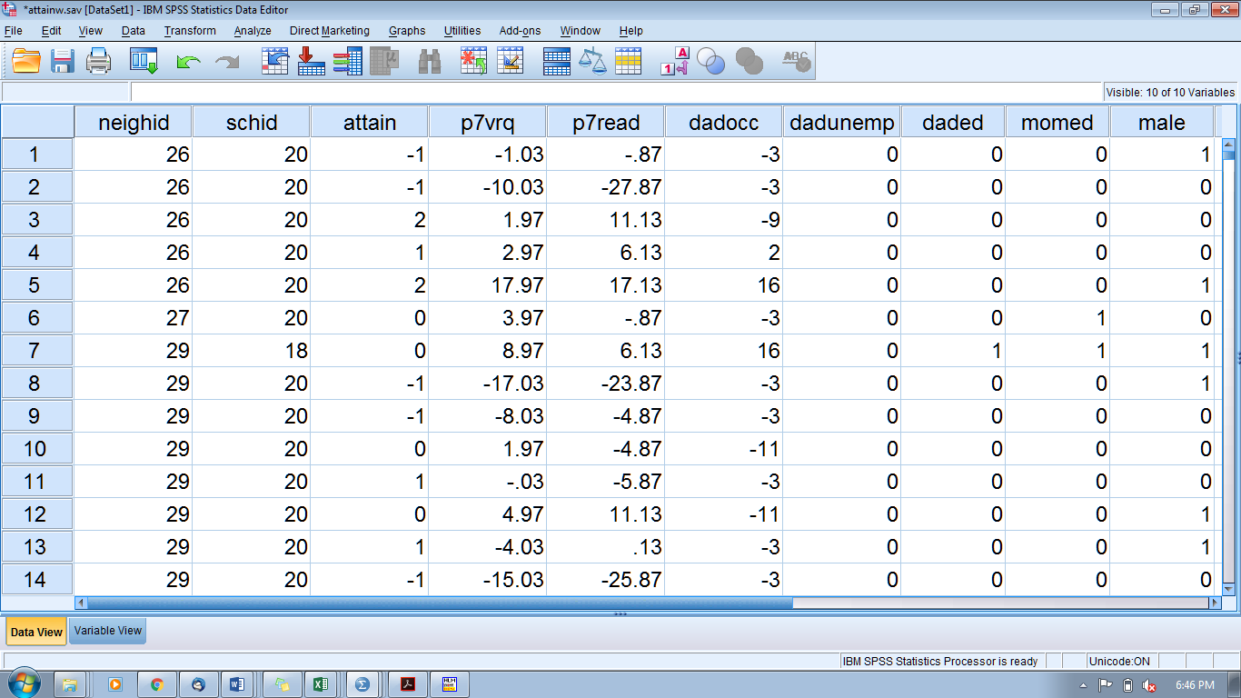

Level-2 Files
Social Deprivation (based on presence of 20 indicators of resources)
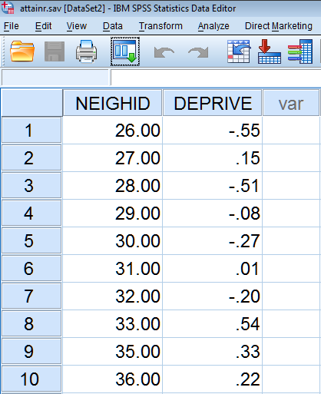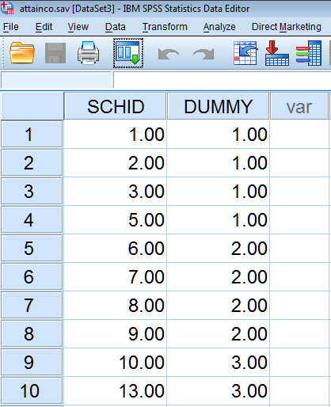

- Specify the level-1 within-cell model, the unconditional model for ATTAIN.

Level-1 Model
ATTAIN_{ijk} = π_{0jk} + e_{ijk}

Level-2 Model
π_{0jk} = θ₀ + b_{00j} + c_{00k}

Final estimation of fixed effects:
Fixed Effect | Coefficient | Standard error | t-ratio | Approx. d.f. | p-value
For INTRCPT1, π₀
INTERCEPT,θ₀ | 0.075355 | 0.072224 | 1.043 | 1769 | 0.297

Final estimation of row and level-1 variance components:
Random Effect | Standard  Deviation | Variance  Component | d.f. | χ² | p-value
INTRCPT1/ ICPTROW,b_{00j} | 0.37566 | 0.14112 | 523 | 904.87451 | <0.001
level-1, e | 0.89390 | 0.79906

Final estimation of column level variance components:
Random Effect | Standard  Deviation | Variance  Component | d.f. | χ² | p-value
INTRCPT1/ ICPTCOL,c_{00k} | 0.27469 | 0.07545 | 16 | 120.42539 | <0.001

Intra-neighborhood correlation (dependency in outcomes for students within the same neighborhood but attend different schools):
$$ICC\left(neighborhood, row\right)=\frac{τ_{b00}}{τ_{b00}+τ_{c00}+σ^{2}}=\frac{0.141}{0.141+0.075+0.799}=0.139$$

Intra-school correlation (dependency in outcomes for students who attend the same school but live in different neighborhoods):
$$ICC\left(school, column\right)=\frac{τ_{c00}}{τ_{b00}+τ_{c00}+σ^{2}}=\frac{0.075}{0.141+0.075+0.799}=0.074$$

Intra-cell correlation (dependency in outcomes of students who live in same neighborhood and attend the same school):
$$ICC\left(within-cell\right)=\frac{τ_{b00}+τ_{c00}}{τ_{b00}+τ_{c00}+σ^{2}}=\frac{0.141+0.075}{0.141+0.075+0.799}=0.212$$

- Complete the level-1 within-cell model.

Level-1 Model
ATTAIN_{ijk} = π_{0jk} + π_{1jk}*(P7VRQ_{ijk}) + π_{2jk}*(P7READ_{ijk}) + π_{3jk}*(DADOCC_{ijk}) + π_{4jk}*(DADUNEMP_{ijk}) + π_{5jk}*(DADED_{ijk}) + π_{6jk}*(MOMED_{ijk}) + π_{7jk}*(MALE_{ijk}) + e_{ijk}

Level-2 Model
π_{0jk} = θ₀ + b_{00j} + c_{00k}
π_{1jk} = θ₁
π_{2jk} = θ₂
π_{3jk} = θ₃
π_{4jk} = θ₄
π_{5jk} = θ₅
π_{6jk} = θ₆
π_{7jk} = θ₇
Because of the sparseness of the data and the potential complexity of the model, the effects of the level-1 explanatory variables are fixed.

- Build a level-2 row-factor model. In this model, the association between social deprivation and educational attainment is fixed.

Level-1 Model
ATTAIN_{ijk} = π_{0jk} + π_{1jk}*(P7VRQ_{ijk}) + π_{2jk}*(P7READ_{ijk}) + π_{3jk}*(DADOCC_{ijk}) + π_{4jk}*(DADUNEMP_{ijk}) + π_{5jk}*(DADED_{ijk}) + π_{6jk}*(MOMED_{ijk}) + π_{7jk}*(MALE_{ijk}) + e_{ijk}

Level-2 Model
π_{0jk} = θ₀ + b_{00j} + c_{00k} + (γ₀₁)*DEPRIVE_{j}
π_{1jk} = θ₁
π_{2jk} = θ₂
π_{3jk} = θ₃
π_{4jk} = θ₄
π_{5jk} = θ₅
π_{6jk} = θ₆
π_{7jk} = θ₇

Final estimation of fixed effects:
Fixed Effect | Coefficient | Standard  error | t-ratio | Approx.  d.f. | p-value
For INTRCPT1, π₀
INTERCEPT,θ₀ | 0.094514 | 0.021185 | 4.461 | 1769 | <0.001
DEPRIVE, γ₀₁ | -0.155997 | 0.025680 | -6.075 | 522 | <0.001
For P7VRQ, π₁
INTERCEPT,θ₁ | 0.027565 | 0.002263 | 12.180 | 1769 | <0.001
For P7READ, π₂
INTERCEPT,θ₂ | 0.026237 | 0.001750 | 14.992 | 1769 | <0.001
For DADOCC, π₃
INTERCEPT,θ₃ | 0.008100 | 0.001361 | 5.953 | 1769 | <0.001
For DADUNEMP, π₄
INTERCEPT,θ₄ | -0.120682 | 0.046779 | -2.580 | 1769 | 0.010
For DADED, π₅
INTERCEPT,θ₅ | 0.143454 | 0.040789 | 3.517 | 1769 | <0.001
For MOMED, π₆
INTERCEPT,θ₆ | 0.059497 | 0.037381 | 1.592 | 1769 | 0.112
For MALE, π₇
INTERCEPT,θ₇ | -0.055941 | 0.028390 | -1.970 | 1769 | 0.049

Final estimation of row and level-1 variance components:
Random Effect | Standard  Deviation | Variance  Component | d.f. | χ² | p-value
INTRCPT1/ ICPTROW,b_{00j} | 0.06593 | 0.00435 | 522 | 554.29863 | 0.159
level-1, e | 0.67446 | 0.45489

Final estimation of column level variance components:
Random Effect | Standard  Deviation | Variance  Component | d.f. | χ² | p-value
INTRCPT1/ ICPTCOL,c_{00k} | 0.06151 | 0.00378 | 15 | 35.39235 | 0.002

The residual variation within cell was reduced from 0.799 to 0.455 and the variance between neighborhoods and schools were substantially reduced (are now near zero).

A model with a random effect of Social Deprivation

Above, the association between neighborhood social deprivation and attainment was assumed invariant across schools. We can test this assumption by allowing this effect to randomly vary (include c_{01k}). A model comparison test based on the deviances produces a nonsignificant result – there is no evidence that the association between neighborhood social deprivation and attainment varies over schools.

In the next model, we include a row-specific predictor random (neighborhood deprivation) and a column-specific predictor random (school dummy variable). This model includes all of the student-level explanatory variables and their associated coefficients, π_{pjk}. θ_{p} is the intercept, the expected value of π_{pjk} (when all explanatory variables are zero). βs are the fixed effects for column-specific predictors; bs are the random effects associated with the column-specific predictors; γs are the fixed effects for row-specific predictors; cs are the random effects associated with the row-specific predictors

Level-1 Model
ATTAIN_{ijk} = π_{0jk} + π_{1jk}*(P7VRQ_{ijk}) + π_{2jk}*(P7READ_{ijk}) + π_{3jk}*(DADOCC_{ijk}) + π_{4jk}*(DADUNEMP_{ijk}) + π_{5jk}*(DADED_{ijk}) + π_{6jk}*(MOMED_{ijk}) + π_{7jk}*(MALE_{ijk}) + e_{ijk}

Level-2 Model
- π_{0jk} = θ₀ + b_{00j} + c_{00k} + (γ₀₁ + c_{01k})*DEPRIVE_{j} + (β₀₁ + b_{01j})*SchoolDUMMY_{k}
π_{1jk} = θ₁
π_{2jk} = θ₂
π_{3jk} = θ₃
π_{4jk} = θ₄
π_{5jk} = θ₅
π_{6jk} = θ₆
π_{7jk} = θ₇

Final estimation of fixed effects:
Fixed Effect | Coefficient | Standard error | t-ratio | Approx. d.f. | p-value
For INTRCPT1, π₀
INTERCEPT,θ₀ | 0.148873 | 0.047311 | 3.147 | 1228 | 0.002
DEPRIVE, γ₀₁ | -0.158655 | 0.026366 | -6.017 | 521 | <0.001
DUMMY, β₀₂ | -0.023178 | 0.017512 | -1.324 | 14 | 0.207
For P7VRQ, π₁
INTERCEPT,θ₁ | 0.027609 | 0.002261 | 12.210 | 1228 | <0.001
For P7READ, π₂
INTERCEPT,θ₂ | 0.026239 | 0.001749 | 15.001 | 1228 | <0.001
For DADOCC, π₃
INTERCEPT,θ₃ | 0.008132 | 0.001360 | 5.979 | 1228 | <0.001
For DADUNEMP, π₄
INTERCEPT,θ₄ | -0.121035 | 0.046741 | -2.589 | 1228 | 0.010
For DADED, π₅
INTERCEPT,θ₅ | 0.142689 | 0.040732 | 3.503 | 1228 | <0.001
For MOMED, π₆
INTERCEPT,θ₆ | 0.061618 | 0.037343 | 1.650 | 1228 | 0.099
For MALE, π₇
INTERCEPT,θ₇ | -0.054709 | 0.028383 | -1.928 | 1228 | 0.054

Final estimation of row and level-1 variance components:
Random Effect | Standard  Deviation | Variance  Component | d.f. | χ² | p-value
INTRCPT1/ ICPTROW,b_{00j} | 0.12591 | 0.01585 | 116 | 125.05766 | 0.266
INTRCPT1/ DUMMY,b_{01j} | 0.03123 | 0.00098 | 116 | 122.68775 | 0.317
level-1, e | 0.67418 | 0.45452
Note: The chi-square statistics reported above are based on only 119 of 524 units that had sufficient data for computation. Fixed effects and variance components are based on all the data.

Final estimation of column level variance components:
Random Effect | Standard  Deviation | Variance  Component | d.f. | χ² | p-value
INTRCPT1/ ICPTCOL,c_{00k} | 0.05328 | 0.00284 | 14 | 27.60991 | 0.016
INTRCPT1/ DEPRIVE,c_{01k} | 0.02108 | 0.00044 | 14 | 9.66845 | >0.500

Three-Level Cross-Classified Models

It is possible to estimate a cross-classified model where either the rows or the column are nested in a higher level factor. For example, repeated measures over time (level-1) can be cross-classified by students (rows) and teachers (columns) and teachers can be nested within schools (clusters), where students can change schools (as they change teachers).

Source: Raudenbush, S.W. & Bryk, A.S. (2002). Hierarchical Linear Models. Applications and Data Analysis Methods (2nd ed., pp. 373-398). Sage Publications.

