**The Rasch Model**

Rasch modeling (Rasch, 1960) provides a framework for examining a particular test and student performance on that test at the item level. The probability of correct response for each item is modeled as a logistic function, where B is examinee ability level and D is the difficulty level of the item, or the ability at which an examinee has a predicted probability .5 of answering the item correctly. When calibrating the items for each of the measures, we use the Rasch model, which is a mathematical model for the relation between the probability of success (P) and the difference between an individual's ability (B) and an item's difficulty (D).

Rasch item calibrations were estimated using Winsteps 3.70 (Linacre, 2010). The typical formulations of this logistic (log-odds) model is , or as seen in typical IRT format, as $P\left(x=1\right|B)= \frac{e^{(B-D)}}{{1+e}^{(B-D)}}$, where *P* is a probability of person *n* responding correctly to item *i*, and the Rasch parameters are *Bn*, the ability of person *n*, and*Di*, the difficulty of item *i*.

Linacre, J.M. (2010). *Winsteps* (Version 3.70.0) [Computer Software]. Beaverton, Oregon: Winsteps.com.

Rasch, G. (1960). *Probabilistic models for some intelligence and attainment tests.* Chicago: The University of Chicago Press.

**TABLE 12.2** Picture Naming W1 Calibration ZOU169WS.TXT Mar 7 23:10 2011

INPUT: 675 PERSON 54 ITEM REPORTED: 675 PERSON 54 ITEM 2 CATS WINSTEPS 3.71.0.1

-----------------------------------------------------------------------------------

PERSON - MAP - ITEM

<more>|<rare>

5 ####### +

T|

.# |

. |

. |

4 . +

.## |

.##### |

.## |

.### S|

.## |

3 .#### +T

##### |

.########## | I0048

.#### | I0042

.####### | I0038 I0044

.###### |

2 .#### + I0045

.###### | I0002 I0019 I0047 I0050

######### M| I0005

.#### |S

###### | I0007 I0020

.### |

1 .#### + I0001 I0004 I0030 I0034 I0054

.## | I0046

.### | I0026

## | I0003 I0032 I0037 I0041 I0051

.## | I0043

. S| I0009

0 .## +M I0027 I0028 I0040

. | I0015 I0035 I0049

.# | I0025

.# | I0036 I0053

.# | I0018

. |

-1 # +

. | I0016 I0029 I0031

. | I0024 I0033 I0039

. T|S I0008 I0022

# | I0006

# | I0012

-2 .# + I0010 I0011

. | I0013

. | I0017

. |

| I0052

. | I0014

-3 . +T

. | I0023

. |

. |

. |

. |

-4 +

. |

|

|

|

-5 + I0021

<less>|<frequ>

EACH "#" IS 5. EACH "." IS 1 TO 4

**TABLE 3.1** Math Education Assessment Uses ZOU994WS.TXT Mar 7 22:12 2011

INPUT: 29160 PERSON 136 ITEM REPORTED: 22564 PERSON 5 ITEM 20 CATS WINSTEPS 3.71.0.1

------------------------------------------------------------------------------------

SUMMARY OF 20557 MEASURED (NON-EXTREME) PERSON

-------------------------------------------------------------------------------

| TOTAL MODEL INFIT OUTFIT |

| SCORE COUNT MEASURE ERROR MNSQ ZSTD MNSQ ZSTD |

|-----------------------------------------------------------------------------|

| MEAN 13.5 5.0 .60 .78 .99 -.1 .99 -.1 |

| S.D. 3.5 .3 1.90 .12 .80 1.3 .81 1.3 |

| MAX. 19.0 5.0 3.97 1.70 6.79 4.5 7.61 5.2 |

| MIN. 2.0 1.0 -3.95 .70 .00 -3.0 .00 -3.0 |

|-----------------------------------------------------------------------------|

| REAL RMSE .89 TRUE SD 1.68 SEPARATION 1.89 PERSON RELIABILITY .78 |

|MODEL RMSE .79 TRUE SD 1.73 SEPARATION 2.18 PERSON RELIABILITY .83 |

| S.E. OF PERSON MEAN = .01 |

-------------------------------------------------------------------------------

MAXIMUM EXTREME SCORE: 1350 PERSON

MINIMUM EXTREME SCORE: 657 PERSON

LACKING RESPONSES: 6596 PERSON

SUMMARY OF 22564 MEASURED (EXTREME AND NON-EXTREME) PERSON

-------------------------------------------------------------------------------

| TOTAL MODEL INFIT OUTFIT |

| SCORE COUNT MEASURE ERROR MNSQ ZSTD MNSQ ZSTD |

|-----------------------------------------------------------------------------|

| MEAN 13.6 5.0 .71 .88 |

| S.D. 4.0 .3 2.37 .33 |

| MAX. 20.0 5.0 5.32 2.11 |

| MIN. 1.0 1.0 -5.31 .70 .00 -3.0 .00 -3.0 |

|-----------------------------------------------------------------------------|

| REAL RMSE 1.02 TRUE SD 2.14 SEPARATION 2.10 PERSON RELIABILITY .82 |

|MODEL RMSE .94 TRUE SD 2.17 SEPARATION 2.31 PERSON RELIABILITY .84 |

| S.E. OF PERSON MEAN = .02 |

-------------------------------------------------------------------------------

PERSON RAW SCORE-TO-MEASURE CORRELATION = .97

CRONBACH ALPHA (KR-20) PERSON RAW SCORE "TEST" RELIABILITY = .88

**TABLE 13.1** Math Education Assessment Uses ZOU994WS.TXT Mar 7 22:12 2011

INPUT: 29160 PERSON 136 ITEM REPORTED: 22564 PERSON 5 ITEM 20 CATS WINSTEPS 3.71.0.1

----------------------------------------------------------------------------------------

PERSON: REAL SEP.: 2.10 REL.: .82 ... ITEM: REAL SEP.: 38.24 REL.: 1.00

ITEM STATISTICS: MEASURE ORDER

------------------------------------------------------------------------------------------------

|ENTRY TOTAL TOTAL MODEL| INFIT | OUTFIT |PT-MEASURE |EXACT MATCH| |

|NUMBER SCORE COUNT MEASURE S.E. |MNSQ ZSTD|MNSQ ZSTD|CORR. EXP.| OBS% EXP%| ITEM G |

|------------------------------------+----------+----------+-----------+-----------+-----------|

| 73 55212 22352 .88 .01|1.03 2.7|1.02 1.5| .80 .81| 59.4 58.2| MFB006U 0 |

| 68 61707 22481 -.02 .01|1.13 9.9|1.13 9.9| .78 .80| 57.5 60.7| MFB006P 0 |

| 75 62842 22305 -.17 .01| .97 -3.1| .98 -2.4| .81 .80| 61.9 59.1| MFB006W 0 |

| 74 62808 22309 -.17 .01| .73 -9.9| .72 -9.9| .85 .80| 68.6 59.5| MFB006V 0 |

| 67 64960 22453 -.52 .01|1.11 9.9|1.11 9.9| .78 .80| 60.7 61.9| MFB006O 0 |

|------------------------------------+----------+----------+-----------+-----------+-----------|

| MEAN 61505.8 22380 .00 .01| .99 1.9| .99 1.8| | 61.6 59.9| |

| S.D. 3318.6 73.5 .47 .00| .14 7.7| .15 7.6| | 3.8 1.3| |

------------------------------------------------------------------------------------------------

**TABLE 18.1** Math Education Assessment Uses ZOU994WS.TXT Mar 7 22:12 2011

INPUT: 29160 PERSON 136 ITEM REPORTED: 22564 PERSON 5 ITEM 20 CATS WINSTEPS 3.71.0.1

----------------------------------------------------------------------------------------

PERSON: REAL SEP.: 2.10 REL.: .82 ... ITEM: REAL SEP.: 38.24 REL.: 1.00

PERSON STATISTICS: ENTRY ORDER

----------------------------------------------------------------------------------------------------------------

|ENTRY TOTAL TOTAL MODEL| INFIT | OUTFIT |PT-MEASURE |EXACT MATCH| |

|NUMBER SCORE COUNT MEASURE S.E. |MNSQ ZSTD|MNSQ ZSTD|CORR. EXP.| OBS% EXP%| PERSON |

|------------------------------------+----------+----------+-----------+-----------+---------------------------|

| 1 17 5 2.37 .78|2.04 1.7|1.99 1.7| -.11 .22| 40.0 51.5| 72 10110101 1|

| 2 20 5 5.32 1.88| MAXIMUM MEASURE| .00 .00|100.0 100.0| 72 10110102 1|

| 3 15 5 1.25 .73|2.13 1.6|2.21 1.7| -.10 .25| 20.0 62.2| 72 10110103 1|

| 4 14 5 .72 .72|2.15 1.6|2.20 1.6| .29 .27| 20.0 59.6| 72 10110104 1|

| 5 13 5 .22 .70| .32 -1.4| .32 -1.3| .75 .29| 80.0 56.3| 72 10110105 1|

| 6 18 5 3.04 .86|1.04 .3|1.04 .3| -.47 .21| 40.0 63.3| 72 10110106 1|

| 7 11 3 3.48 1.18| .59 -.4| .54 -.4| .94 .21| 66.7 67.9| 72 10110107 1|

| 8 8 2 4.17 1.95| MAXIMUM MEASURE| .00 .00|100.0 100.0| 72 10110108 1|

| 9 16 5 1.79 .75|3.91 3.1|3.88 3.1| -.21 .24| 20.0 58.9| 72 10110109 1|

| 10 5 2 -.27 1.15| .42 -.5| .42 -.5| 1.00 .16|100.0 52.9| 72 10110110 1|

| 11 DROPPED | | | | | 72 10110111 1|

| 12 18 5 3.04 .86| .73 -.4| .75 -.3| .62 .21| 80.0 63.3| 72 10110112 1|

| 13 16 5 1.79 .75|1.39 .8|1.41 .8| .18 .24| 40.0 58.9| 72 10110113 1|

| 14 DROPPED | | | | | 72 10110114 1|

| 15 18 5 3.04 .86|1.04 .3|1.04 .3| -.47 .21| 40.0 63.3| 72 10110115 1|

| 16 DROPPED | | | | | 72 10110116 1|

| 17 18 5 3.04 .86| .60 -.7| .59 -.7| .75 .21| 80.0 63.3| 72 10110117 1|

| 18 DROPPED | | | | | 72 10110118 1|

| 19 6 2 1.08 1.19| .02 -1.8| .02 -1.8| .00 .14|100.0 64.7| 72 10110119 1|



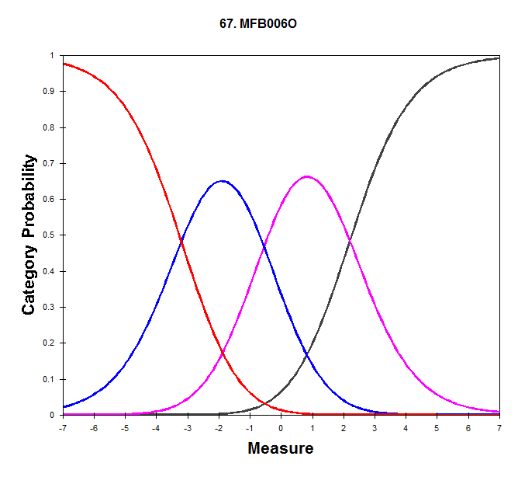



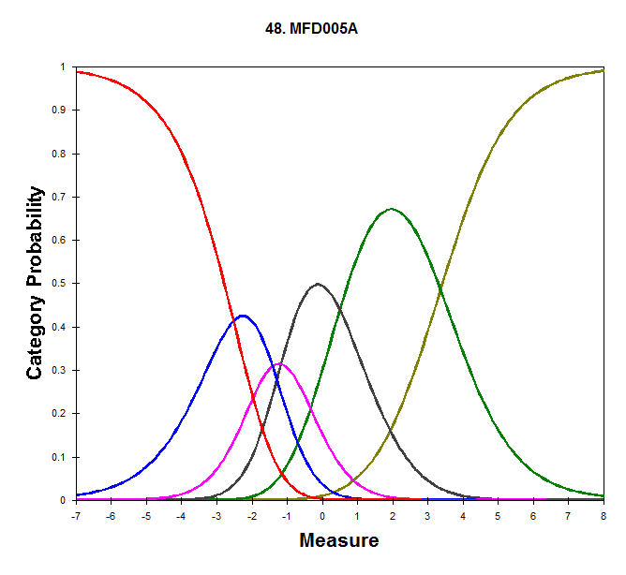

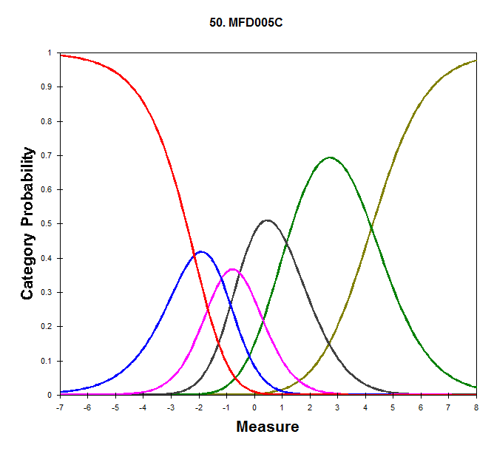

Survey Data Analysis Winsteps Tables

*Summary Statistics*

* 1. Person & Item Summaries

Real results: based on the actual data (where misfit reflects the probabilistic nature of data)

Model results: based on the presumption that the data fit the model

Adj. SD: True-SD, removes error variance from observed variance

*Item Analysis*

* 1. Item Map from most difficult (top) to easiest (bottom); Persons are located on the left
  2. Item Statistics
* Raw score, measure (difficulty), error,
* INFIT is an information-weighted fit statistic, which is more sensitive to unexpected behavior affecting responses to items near the person's measure level.
* OUTFIT is an outlier-sensitive fit statistic, more sensitive to unexpected behavior by persons on items far from the person's measure level.
* For both, values of 2.0 or greater are really problematic. It suggests that the observations do not conform to what the model expects.
* Score corr. (correlation between item score and ability measure)

29.# Empirical & Model ICCs

* The model ICC is shown by '**.**'
* Observed average scores on the items are shown by 'x'
* When '**.**' and 'x' coincide, '**\***'is shown

30.0 DIF, Differential Item Functioning

DIF Contrasts indicate differential functioning by group membership – BIAS

*Person Analysis*

* 1. Person Map from highest ability (top) to lowest ability (bottom)

Items are also located on the left

* 1. Person statistics

Raw score, measure (ability), error;

Outfit mnsq (person fit): >2.0, person responses does not fit the model

*Test Score Analysis*

* 1. Score-to-Measure Table
* Conversion of observed score to measure (ability); E = extreme scores
* Resulting scaled mean (umean) and SD (uscale)
* Scatter plot of raw score and measure; persons & items distribution under scatter plot
  1. Table of Sample Norms

Raw scores and Measures are provided, with corresponding Normed scores

The norms are on a scale of Mean = 500 and SD = 100, with frequencies and percentiles