EPSY 5245: Advanced Survey Data Analysis

Legacy Clustered Bar Charts

Graphs > Legacy dialogues > Bar

- Clustered > Summaries for groups of cases
- Bars Represent: % of cases

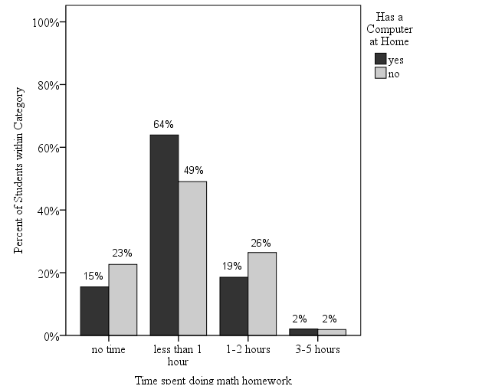

Figure 1. Time spent on doing math homework by presence of a computer at home.
Source: TIMSS, 1994.

Yields bars representing the percent of students within secondary category (has a computer). So they sum to 100% for Yes – has a computer and 100% for No – does not have a computer. This is NOT helpful.

Chart Building Clustered Bar Charts

Graphs > Chart Builder

- Select Clustered Bar Chart (double click)
- Drag X-axis category variable to “X-Axis?”
- Drag clustering variable to “Cluster on X”
- Edit Properties of “Bar1”
  - Set Statistic to “Percentage (?)”
  - Set Parameters to “Total for Each X-Axis Category”
  - Click “Apply”
- Edit Properties of “X-Axis (Bar 1)” and other Bars as needed
  - Eliminate any unwanted categories (e.g., missing)

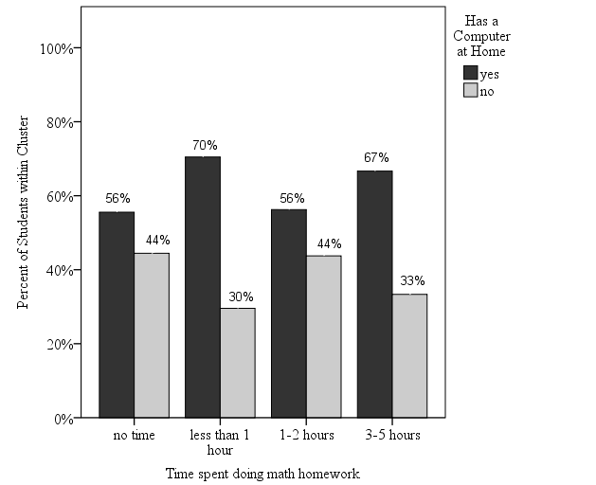

Figure 1. Time spent on doing math homework by presence of a computer at home.
Source: TIMSS, 1994.

These bars sum to 100% within category of time spent on homework. Turns out to be a nonsignificant association (χ²(3) = 6.5, p=.088).

